**Name\_\_\_\_\_\_\_\_\_\_\_\_\_\_\_**

**Grade 6 Social Studies**

**P.A.T.**

**Review Package**

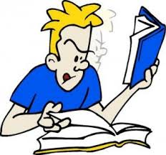

Achievement Test Date – June 20, 2013

Concepts to be Familiar With:

Introduction/Getting Started:

* Democracy
* Majority rule
* Justice, equity, representation, freedoms – 4 principles
* Representative/Direct democracy
* Rights and responsibilities
* Importance of voting
* Who can vote
* Equality vs. Equity

Chapter 1 – Shaping Society Together

* Constitution
* Rules
* Citizenship
* Canadian citizen

Chapter 2 – Democracy in Action

* Rights and freedoms
* Individual rights
* Collective rights
* Common good
* Canadian Charter of Rights and Freedoms
* Democratic rights
* Facts vs. Opinions
* Direct democracy
* Who makes decisions about rules?

Chapter 3 – Democracy in Ancient Athens

* Citizens, Metics, and slaves – their roles and the differences between them
* Greece map
* Assembly, council of 500, courts – how were decisions made?
* Influence of women
* Equity and fairness

Chapter 4 – The Iroquois Confederacy

* Chiefs vs. Clan mothers
* Wampum belts
* Consensus
* Grand council – how were decisions made?
* Role of men and women
* 7th generation

Chapter 5 – local government

* Responsibilities of Local Government
* Bylaws
* Services and taxes
* How is local government organized
* How can you participate in local government
* School boards

Chapter 6 – Provincial Government

* Responsibilities of Provincial Government
* Services
* How are laws made?
* Government structure and roles
* How can you participate in provincial government
* MLA’s vs. Cabinet Ministers
* Lieutenant Governor Roles

Chapter 7 – Making a Just and Fair Canada

* Canadian Charter of Rights and Freedoms
* How does the charter protect us?
* How does the charter protect Francophones?
* How does the charter protect Aboriginals?
* Making decisions
* How is the charter entrenched in the constitution?
* Grand Paix de Montreal vs. The charter

Chapter 8 – Voices for Change

* Minority organizations
* Accountability
* Individual vs. Group participation

Name\_\_\_\_\_\_\_\_\_\_\_\_\_\_\_\_\_

Social 6 Year End Review Questions

1. What is democracy?

2. What is meant by “majority rules?”

3. Which principle of democracy from the following is represented by each picture below? [**Representation/freedoms/equity]** Write your answers and reasons in the boxes below. The first principle has been done for you.

|  |  |
| --- | --- |
| ABSS6-TR_4_scalesjustice_4649185  **Justice** | 5_Peace rally CAL1028-CDNPeac |
| j0241159 | Female Mounties 3267688 |

4. Define the difference between equality and equity.

5. The following statements outline some of the rights guaranteed by Canada’s *Charter of Rights and Freedoms*:

We have the freedom to believe what we like and to speak and write about our opinions.

**The *Charter of Rights and Freedoms***

Canada is a bilingual nation, and both French and English are official languages.

Aboriginal people have special rights to the land.

What do these examples from the Canadian *Charter of Rights and Freedoms* tell us about Canada as a nation and what we value?

What are some of the responsibilities that come with the rights set out   
in the *Charter*?

What are other rights and freedoms that the *Charter* gives you?

Use the following timeline to answer the next 2 questions.

**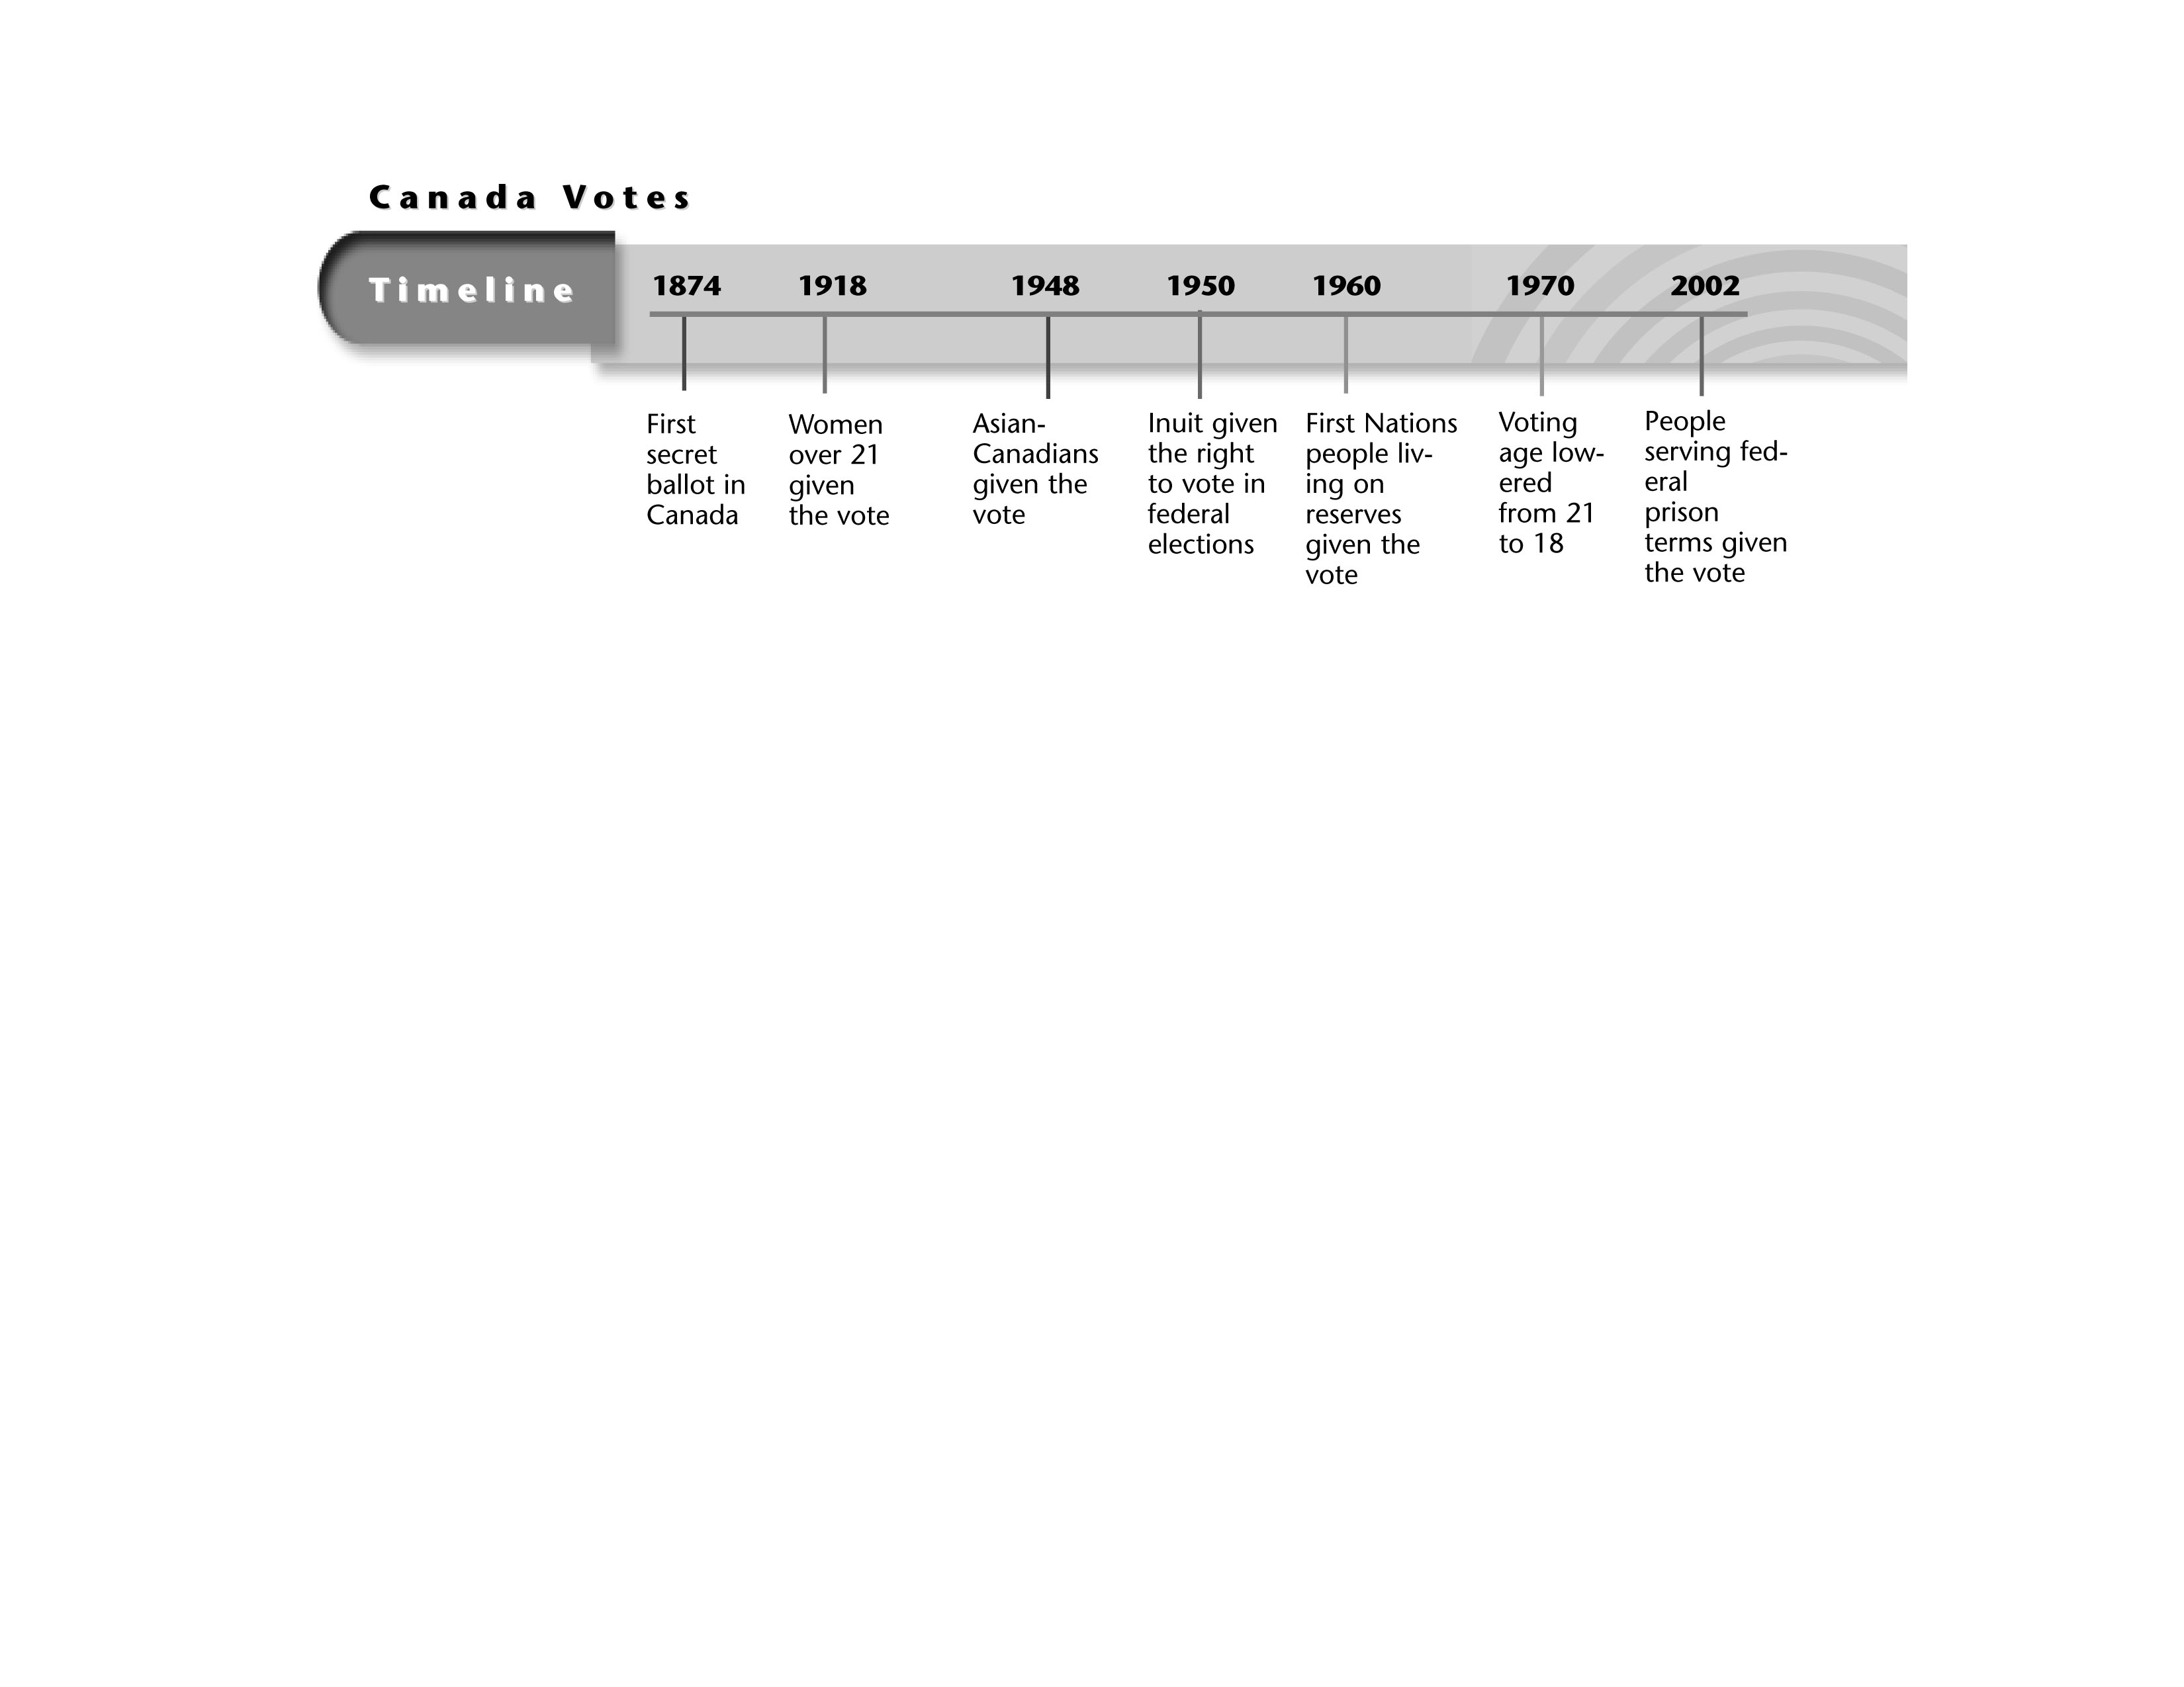**

6. What are 2 groups in the past that have not been allowed to vote in Canada?

7. Why do you think people fought to change the law to allow more people to vote?

\_\_\_\_\_\_\_\_\_\_\_\_\_\_\_\_\_\_\_\_\_\_\_\_\_\_\_\_\_\_\_\_\_\_\_\_\_\_\_\_\_\_\_\_\_\_\_\_\_\_\_\_\_\_\_\_\_\_\_\_\_\_\_\_\_\_\_\_\_\_\_\_\_\_\_\_\_\_\_\_

\_\_\_\_\_\_\_\_\_\_\_\_\_\_\_\_\_\_\_\_\_\_\_\_\_\_\_\_\_\_\_\_\_\_\_\_\_\_\_\_\_\_\_\_\_\_\_\_\_\_\_\_\_\_\_\_\_\_\_\_\_\_\_\_\_\_\_\_\_\_\_\_\_\_\_\_\_\_\_\_

8. What is representative democracy?

9. What is the most important law of the land called? What is one DOCUMENT that is underneath of this law that all Canadians should know?

10.Use the information in this news article to help you answer the following questions.

*Ottawa Chronicle,* 1982

**Charter Becomes Part of Canada’s Constitution**

As of July 1, 1982 the Charter of Rights and Freedoms is now ***“***entrenched***”*** as part of the Canadian Constitution. By doing this, the governments of Canada

have ensured that the Charter has become a permanent part of the most important law in Canada, *guaranteeing* rights and freedoms to all Canadians.

What event is being described?

Why is it important?

11. What criteria must be met to ensure that someone is an eligible voter? (4 things)

12. Why is it important to vote?

13. Why is it important to have rules in society?

14. Why is the Canadian constitution an important document?

15. Define citizen.

16. True or False: Everyone living in Canada is a Canadian citizen.

17. Define and give an example of individual rights

Definition –

Example –

18. Define and give an example of collective rights.

Definition –

Example –

19. What is meant be the saying “for the common good.”

20. Define direct democracy.

21. What are our democratic rights? Complete the following information.

|  |  |
| --- | --- |
| Democratic rights  of citizens |  |
| How often elections must happen |  |
| How often government must meet |  |

22. Give an example of a fact and an opinion.

Fact –

Opinion -

23. Define Rule of Law.

24. Who makes decisions about rules in our Country? (Hint: There are two main ‘players’)

Name\_\_\_\_\_\_\_\_\_\_\_\_\_\_\_\_\_\_\_\_

25. Use the following map of Ancient Greece to answer the next questions

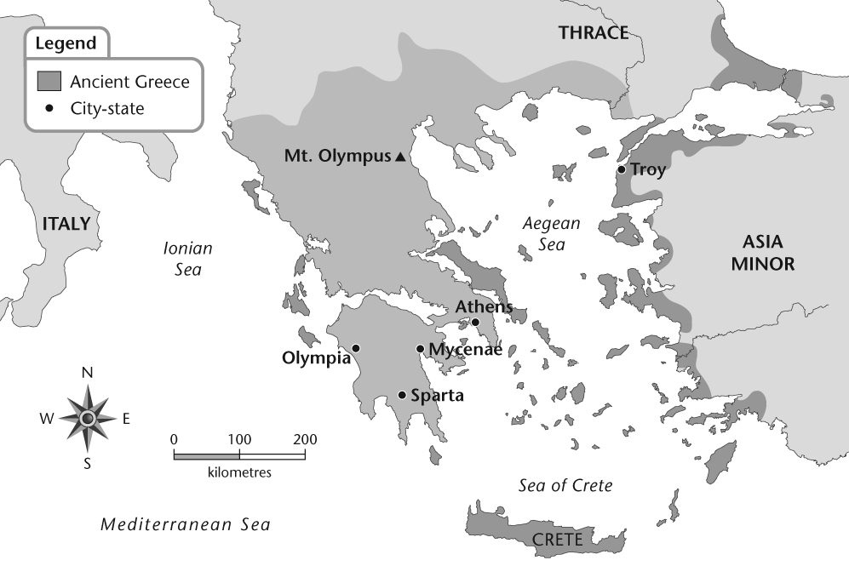

Daniel studied the map of Ancient Greece and made some observations about what he saw. He has asked you to look over his work and help him fix any errors in his geographic thinking. You discover that two of Daniel’s observations are inaccurate. Indicate which two are accurate and which two are inaccurate, according to the information on the map.

|  |  |  |
| --- | --- | --- |
| Daniel’s Observations | Accurate | Inaccurate |
| 1. Athens is about 300 kilometres from Olympia. |  |  |
| 2. To get from Athens to Olympia, people would have to travel southwest. |  |  |
| 3. Athens is in the western half of Greece. |  |  |
| 4. Olympia is near the Mediterranean Sea, while Athens has access to the Sea of Crete. |  |  |

26. Use the information to answer the questions on the following page.

|  |  |  |
| --- | --- | --- |
| Roles | Athenian Male Citizens | Athenian Females |
| Schooling | • outside the home at school  • reading, writing, music, literature | • at home by their mothers  • weaving, spinning and child care |
| Sports | • encouraged to play many sports  • part of training for army service | • typically did not participates in organized sports |
| Army service | • compulsory from age 18–20 | • did not participate in the army |
| Decision making | • male citizens had full rights to participate as of age 20 | • did not participate in decision making |
| Household duties | • wage earner, represent the family’s interests | • manage the house—servants, finances, food preparation |
| Child care | • had little to do with raising children  • as boys grew up, their fathers played a greater role in their lives | • had the major responsibility for raising the children  • as girls grew up, their mothers were responsible for their education and training |

Think about the information in the chart and compare it to the definition of equity. How much equity do you think there was in Ancient Athens? Explain your answer using many examples from the chart and what you have learned in this chapter.

Choose one of the roles from the chart that you think would be the most important to change in order to make that society more equitable. Explain your answer.

27. Democracy as a form of government can be divided into these two categories:

– direct democracy

– representative democracy

Though there are some similarities between the two, there are some important differences as well. For each of the characteristics of democracy listed in the chart below, place an X in the appropriate column. (D= Direct; R=Representative, B=Both.)

|  |  |  |  |
| --- | --- | --- | --- |
| Characteristics Of Democracies | D | R | B |
| 1. **All** eligible adult citizens have the opportunity to participate. |  |  |  |
| 2. Individuals are chosen to make decisions on behalf of the group. |  |  |  |
| 3. The wishes of the majority are usually followed. |  |  |  |
| 4. Laws are made by all citizens voting for them. |  |  |  |
| 5. All citizens have certain rights and freedoms. |  |  |  |
| 6. Some minority groups have special rights and protections.. |  |  |  |

28. Complete the following chart explaining the different roles of citizens, metics and slaves in Ancient Athens

|  |  |
| --- | --- |
|  | Roles |
| Citizens |  |
| Metics |  |
| Slaves |  |

29. Using the words “Assembly, Council of 500, and The Court” explain how decisions were made in Ancient Athens.

30. What was the role of the women in Ancient Athens?

31. Who was Hiawatha?

32. Define a wampum belt and explain why they are significant to the Iroquois society?

33. Explain consensus.

34. Explain the roles of the following people in the Iroquois Confederacy.

|  |  |
| --- | --- |
|  | Roles |
| Chiefs |  |
| Clan Mothers |  |

35. How were decisions made in the Iroquois Confederacy?

36. What was the importance of the 7th generation?

37. Read the following information to help you answer the next questions.

***David’s Jot Notes***

|  |  |  |  |
| --- | --- | --- | --- |
| Daily Life in Different Societies | | | |
| Iroquois Confederacy | | Ancient Athens | |
| Men | Women | Men (male citizens) | Women |
| – organized groups to hunt and fish  – built longhouses and canoes  – organized team sports for men  – fought wars | – owned the property and homes  – raised corn, beans, and squash  – made wampum belts | – owned property  – received an education in math and literature at an early age  – required to train for participation in the military | – did not own property  – spent most of their time at home and raised children  – married as early as 13 years of age  – women in rich families were educated to run a household of servants and slaves; in poorer families, they worked with men |

|  |  |
| --- | --- |
| Decision Making in Different Societies | |
| Iroquois Confederacy | Athenian Democracy |
| – consensus among the original five nations  – if groups fail to reach consensus, chiefs get advice from communities and the process starts again  – clan mothers give chiefs advice, ensure decisions match with great law of peace  – men were chiefs of the clans and members of grand council | – majority rule  – male citizens make and vote on laws in the assembly  – male citizens participated in juries  – women were not allowed to participate in decisions |

Think about David’s jot notes and think about what you learned in the chapter; then show your level of agreement with the statement below by marking an X on the line provided.

*The way society was organized in the Iroquois Confederacy and Ancient Athens affected the way that government was organized in both of these societies.*

**Fully disagree**

**Fully agree**

Complete the following sentence to explain your reasons for your rating

The reason I put my X where I did is because

37. What services are provided by the local government? (8 services)

\*

\*

\*

\*

\*

\*

\*

\*

38. Why do local governments collect taxes?

39. What is a bylaw?

40. How is a bylaw created?

41. Complete the following table that explains the organization of local government.

**Organization of Local Government**

|  |  |  |
| --- | --- | --- |
| **Local Government** | **Top Elected Official** | **Council** |
| **Urban** |  |  |
| **Rural** |  |  |
| **First Nations** |  |  |
| **Metis** |  |  |
| **School Boards** |  |  |

42. How can citizens participate in local government?

43. How are local governments elected?

44. Complete the following chart to explain the different types of schools

|  |  |
| --- | --- |
| **Type of School** | **Information Bit** |
| **Public Schools** |  |
| **Separate Schools** |  |
| **Francophone Schools** |  |
| **Charter Schools** |  |
| **First Nations Schools** |  |

45. What are the responsibilities of the Local Government? (Hint: There are 4 major ones)

Name\_\_\_\_\_\_\_\_\_\_\_\_\_\_\_\_\_\_\_

46. The chart below describes six steps in Alberta’s electoral process. In the boxes on the right use the numbers from 1 to 6 to indicate the correct order for these steps.

|  |  |
| --- | --- |
| Steps in the Electoral Process | Order |
| Campaigning Begins  • each**candidate** “campaigns” to encourage people to vote for him/her |  |
| A New Government Is Formed  • the party that has the most candidates elected to seats in the legislature becomes the government  • the leader of the party with the most seats in the Legislature becomes the Premier |  |
| An Election Is Called  • the Lieutenant Governor “calls an election” at the request of the Premier |  |
| Election Day Arrives  • on election day, people go to polling stations to vote  • each person casts a ***secret ballot*** for the candidate of their choice |  |
| Parties Present Candidates  • ***political parties*** present candidates to run inconstituencies  • if the candidate wins she/he gets a seat in the Legislature |  |
| A Winner Is Declared  • the ballots are counted  • the candidate with the most votes wins the ***constituency***  • every constituency is equal to one seat in the Legislature |  |

47. In the chart on the previous page, four terms are *boldfaced* and ***italicized****.* Choose two of the terms and explain them.

Term 1

Term 2

48. List the services provided by the provincial government. (9 services)

\*

\*

\*

\*

\*

\*

\*

\*

\*

49. What are the responsibilities of the provincial government? (Hint: There are 3 major ones)

50. Explain the roles of an MLA and a cabinet minister in the following chart

|  |  |
| --- | --- |
| **MLA** | **Cabinet Minister** |
|  |  |

51. Explain the steps that are taken to make a law in Alberta.

52. Complete the following table explaining the structure of the provincial government

**Structure of the Provincial Government**

|  |  |  |  |
| --- | --- | --- | --- |
| **Title/Name of Current Member** | **Definition**  **of Role** | **How Person is Chosen** | **Responsibilities** |
| Lieutenant  Governor  \_\_\_\_\_\_\_\_\_\_\_\_\_\_\_ |  |  |  |
| Premier  \_\_\_\_\_\_\_\_\_\_\_\_\_\_\_ |  |  |  |
| MLA  \_\_\_\_\_\_\_\_\_\_\_\_\_\_\_  (my MLA)  -member of a party in power  -member of a party in opposition |  |  |  |
|  |  |  |
| Cabinet Minister |  |  |  |

53. What is the difference between an MLA and a cabinet minister?

54. What are the 6 roles of a Lieutenant governor?

55. How can you, as a citizen, participate in provincial government?

56. In the column to the left of each statement, place the number of the *Charter of Rights and Freedoms* that matches the statement.

|  |
| --- |
| Charter Right |
| 1. Fundamental Freedoms |
| 1. Democratic Rights |
| 1. Mobility Rights |
| 1. Legal Rights |
| 1. Language Rights |

|  |  |
| --- | --- |
|  | **Actions Taken by People or Organizations That Are Supported by the Charter** |
|  | A police officer arrests a woman and puts her in jail after he tells her why she has been arrested and informs her of her right to contact a lawyer. |
|  | A group of English- and French-speaking people living in Québec decide to challenge the French only language law in court. |
|  | People from Nova Scotia migrate to Alberta for the good jobs available there. |
|  | A newspaper prints a story about a company that cheated its employees. The company loses business and must shut down. The newspaper has proof to back up its story. |
|  | The government of Canada allows Canadian citizens from Afghanistan to vote even though Canada is at war in Afghanistan. |

57. a) Name the 8 ways that the charter protects us.

The Charter Protects Us By........

b) How does the Charter protect Francophone rights?

c) How does the Charter protect Aboriginal rights?

58. Use the following chart to answer the next questions

|  |
| --- |
| Facts a student recorded about the Treaty of **La Grande Paix de Montréal**  1. More than 40 First Nations groups were invited to Montréal.  2. Many groups travelled long distances to get to the meeting.  3. A consensus model was used to arrive at decisions at the meeting.  4. Each group wanted to be recognized as independent.  5. The French recognized the First Nations people’s rights to territory.  6. The First Nations groups agreed to settle disagreements peacefully.  7. Each First Nations group was considered equal. |

One of the most important outcomes of the Treaty was the recognition of the collective rights and identity of First Nations people.

Circle the facts about the Treaty that best support this statement. Explain your answer.

59. Complete the following table explaining each right or freedom found in the charter

|  |  |
| --- | --- |
| Right or Freedom | Explanation |
| Fundamental Freedoms |  |
| Democratic Rights |  |
| Mobility Rights |  |
| Legal Rights |  |
| Equality Rights |  |
| Language Rights |  |
| Minority Language Rights |  |
| General |  |

60. Who makes decisions about cases regarding the Canadian Charter of Rights and Freedoms?

61. Representatives in a democracy show that they are accountable in many ways, including

– Listening to constituents, responding to their e-mails and phone calls

– Presenting the concerns of constituents’ concerns at government meetings

– Keeping constituents informed about what their representative is doing

Circle the e-mail that you think demonstrates the best example of accountability.

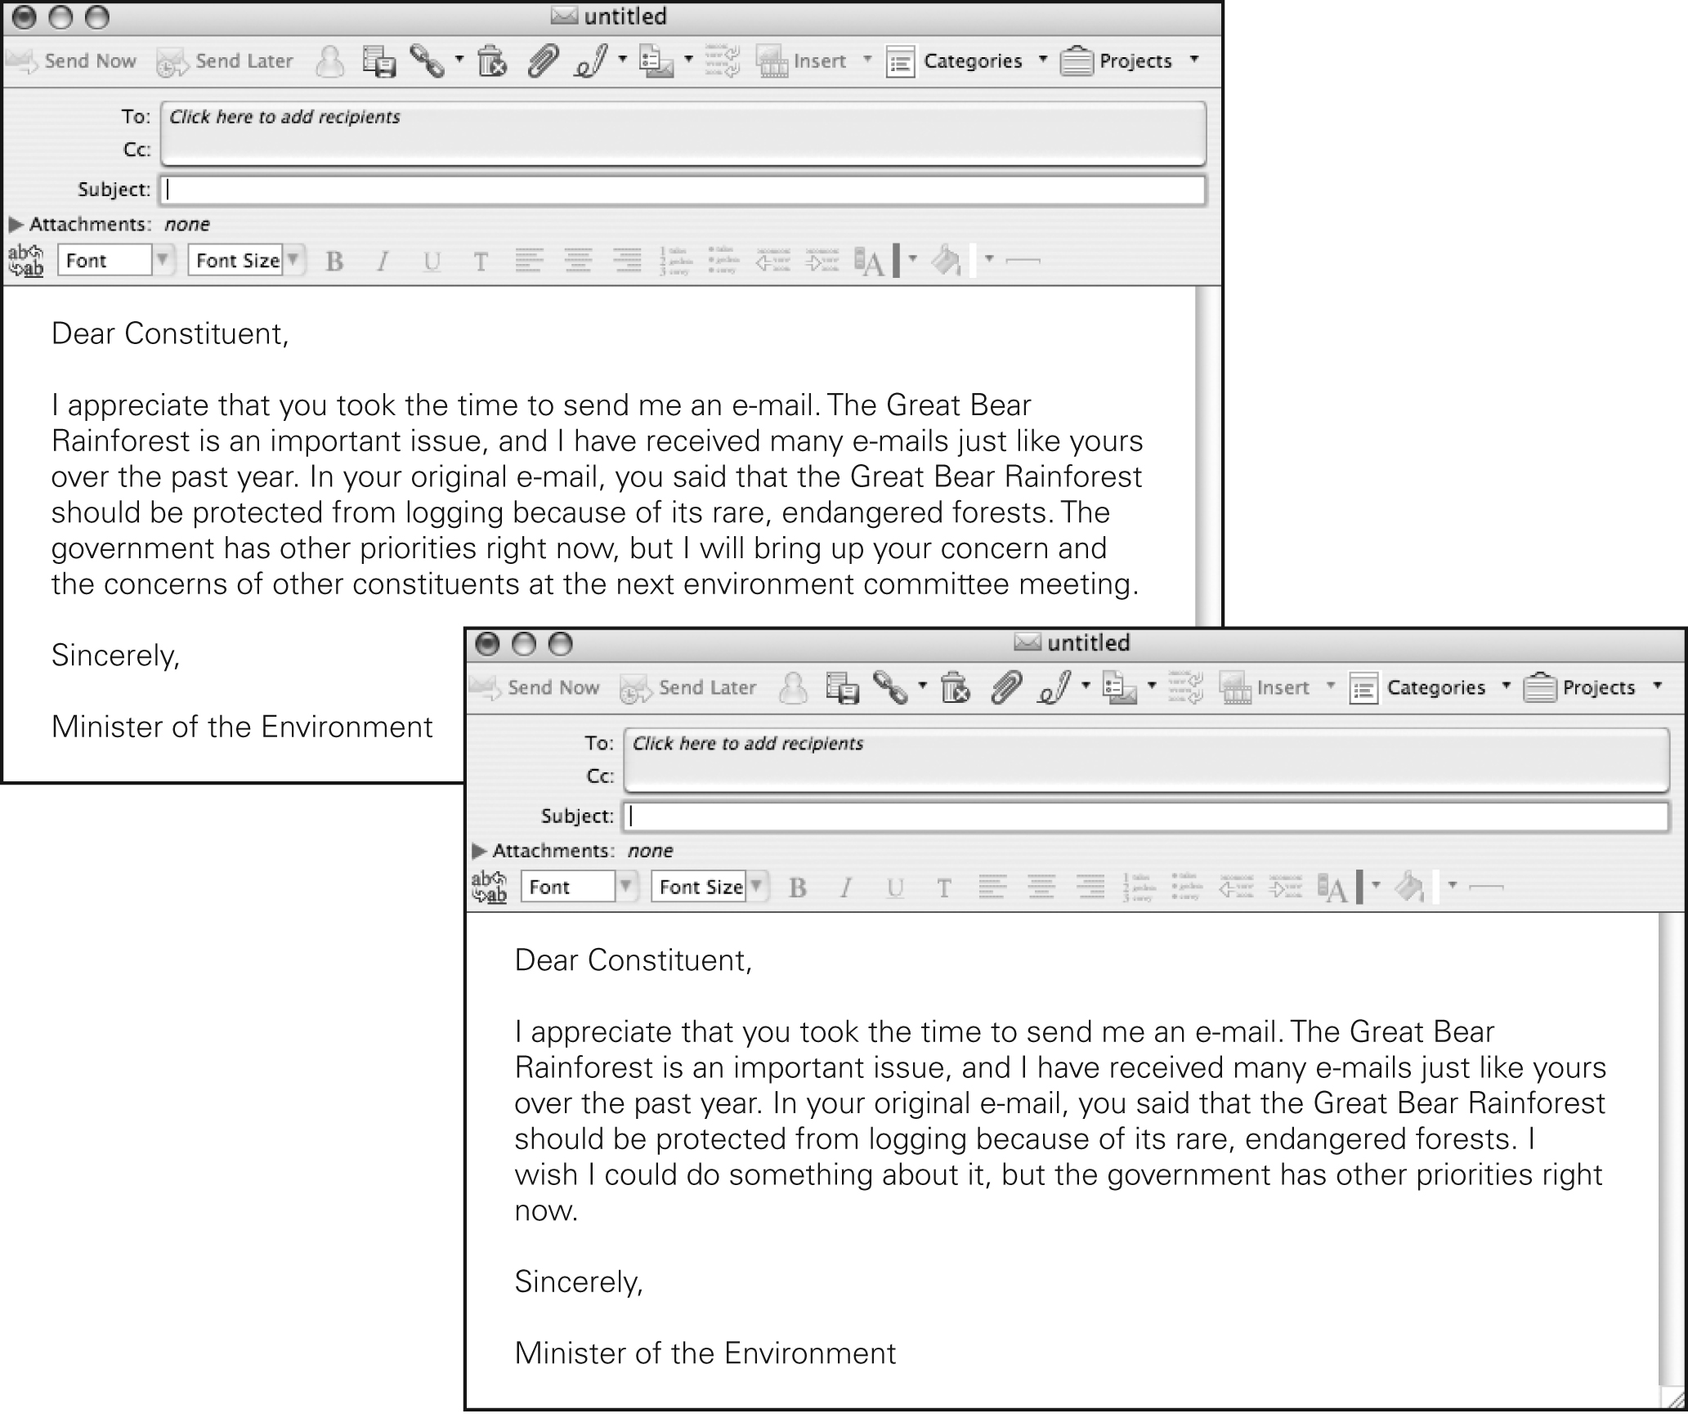

**A**

**B**

A

The e-mail I chose is the best example of an elected representative demonstrating accountability to constituents because

62. Compare the Canadian Charter of Rights and Freedoms and the Grand Paix de Montreal in the following Venn Diagram

Charter Grand Paix de Montreal

63. Why did Canadians push for the Charter to be entrenched into the constitution?

64. Explain what rights each of the following groups protect for each group (collective rights)

|  |  |
| --- | --- |
| **Organization** | **What they Protect** |
| **Metis Nation of Alberta Association**  **(MNAA)** |  |
| **L’Aaaociation canadienne-francaise de l’Alberta (ACFA)** |  |
| **First Nations Authorities (FNA)** |  |

65. A Statistics Canada survey conducted in 2001 asked people across Canada to identify their ethnic origin. The graph below represents some of the results from Alberta’s two largest cities.



Lauren wrote down things she could observe from the graph. Then she realized that two of her original observations about the graph were not accurate. Cross off the two observations that are not correct according to the information on the graph.

|  |
| --- |
| Observations from the graph |
| • Most Albertans living in Calgary and Edmonton said their ethnic origin was something other than French.  • More people in Alberta’s two largest cities said that their ethnic origin was French rather than Scottish.  • The German population in Edmonton is as large as the Chinese population in Calgary.  • The smallest population is the Polish population in Calgary.  • The largest population in Edmonton is the Ukrainian population. |

For the two observations that you crossed off, explain why.

Lauren also wrote down two things she could infer or conclude from the graph.

1. People in Edmonton could experience many types of cultural traditions and celebrations.

2. The population of Alberta’s two largest cities in 2001 was less diverse than in the past.

Do you agree with Lauren’s first inference that she made from the evidence in the graph? Explain why.

Do you agree with Lauren’s second inference that she made from the evidence in the graph? Explain why.

\_\_\_\_\_\_\_\_\_\_\_\_\_\_\_\_\_\_\_\_\_\_\_\_\_\_\_

\_\_\_\_\_\_\_\_\_\_\_\_\_\_\_\_\_\_\_\_\_\_\_\_\_\_\_\_\_\_\_\_\_\_\_\_\_\_\_\_\_\_\_\_\_\_\_\_\_\_\_\_\_\_\_\_\_\_\_\_\_\_\_\_\_\_\_\_\_\_\_\_\_\_\_\_\_\_\_\_\_\_\_\_\_\_\_\_\_\_\_\_\_\_\_\_\_\_\_\_\_\_\_\_\_\_\_\_\_\_\_\_\_\_\_\_\_\_\_\_\_\_\_\_\_\_\_\_\_\_\_\_\_\_\_\_\_\_\_\_\_\_\_\_\_\_\_\_\_\_\_\_\_\_\_\_\_\_\_\_\_\_\_\_\_\_\_\_\_\_